Group 10

Author: 叶菁菁

User Manual

Pocker Game

Table of Contents

System Architecture 2

player Manual 2

## System Architecture

The system architecture is shown below:

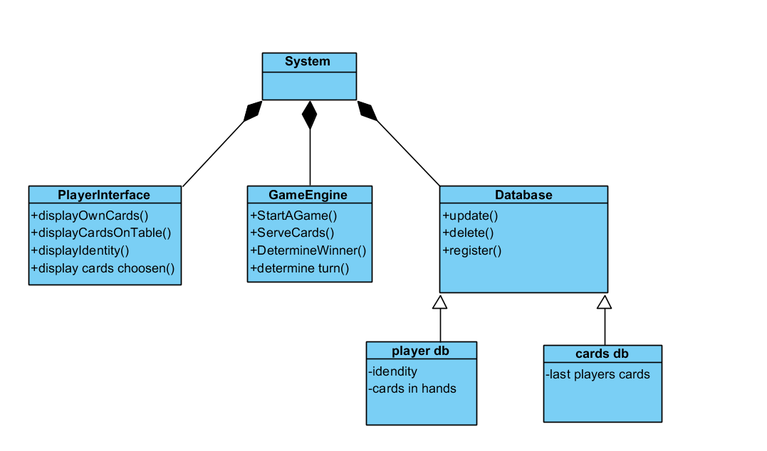

## player Manual

* start the game by press start button

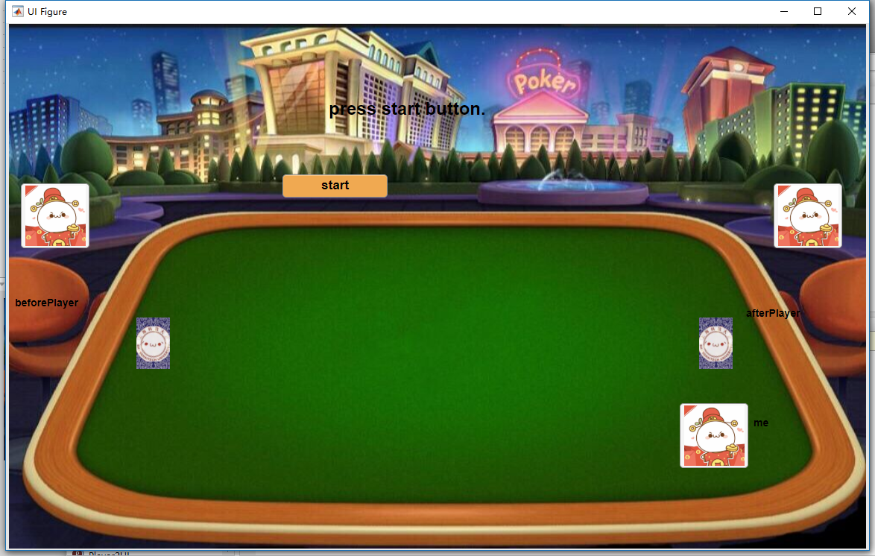

#### press lord / give up to rob lord

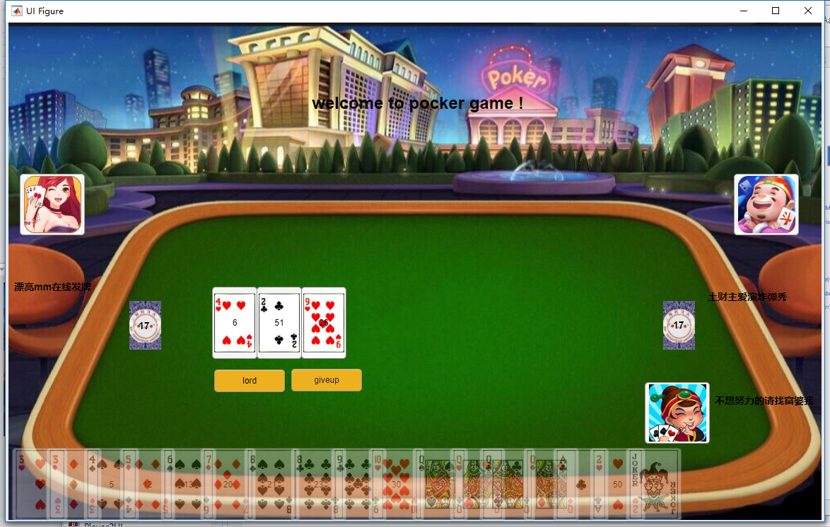

* Player 1 is the beautiful girl
* Player2 is rich woman
* Player3 is rich lord who likes play boom show

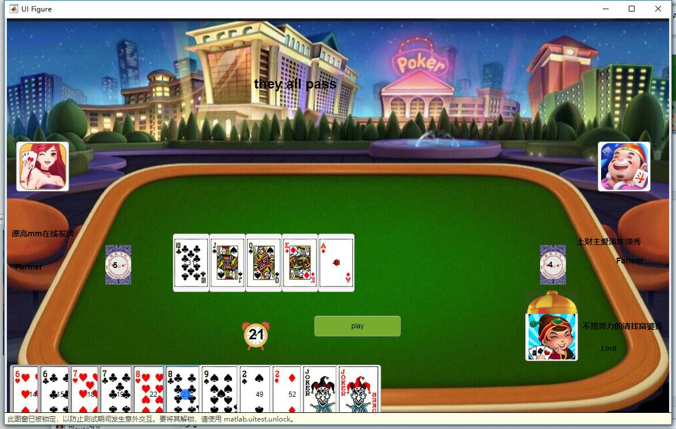

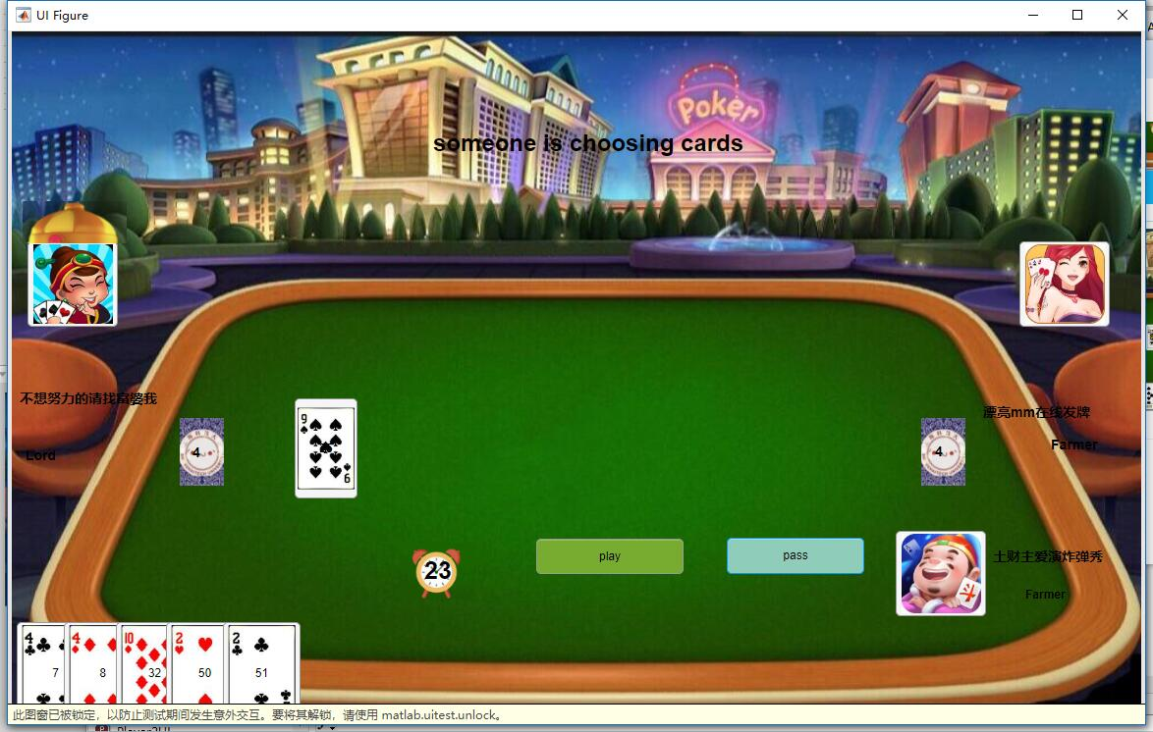 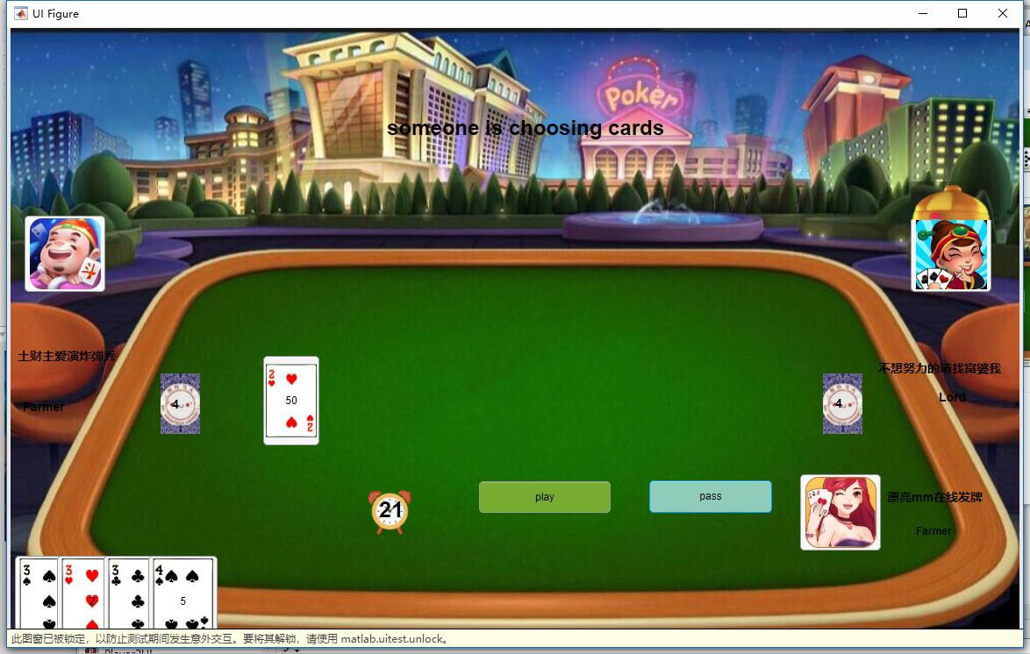

Lord will have a little hat on his head to show he/she is the lord

### start to play the cards

Cards will be send out, lord has 20 cards , farmers has 17 cards

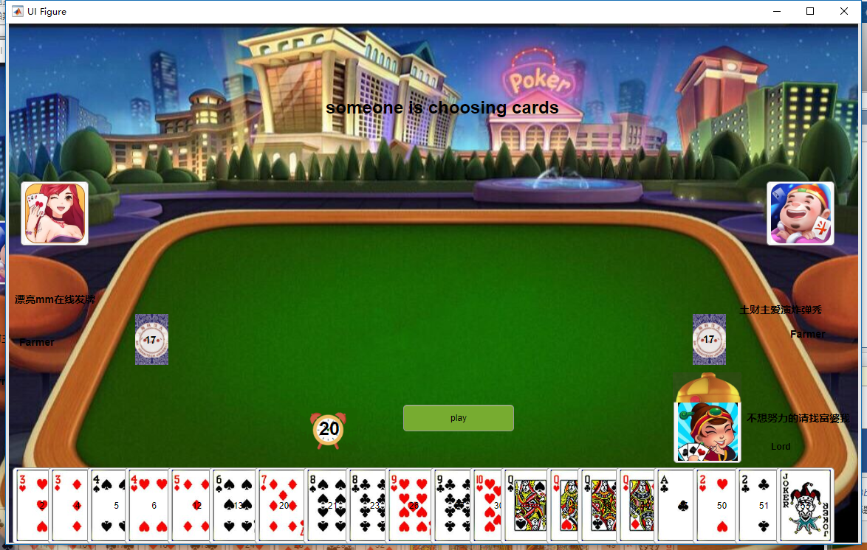

Everyone has 25 seconds to choose and play the cards, there is a little clock to tell you the time. If time is out pass his/her turn

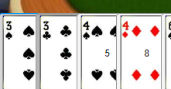 When choose the cards, the cards will be grey

The first player can not pass and then you can pass



When two players pass, the has played cards stored change to []. So current player can play anything again just like first one to play the game and also his pass button will not be enable or visible.



### If cards you choose is ilegal



### anyone has cards less than 3, there will be an alarm

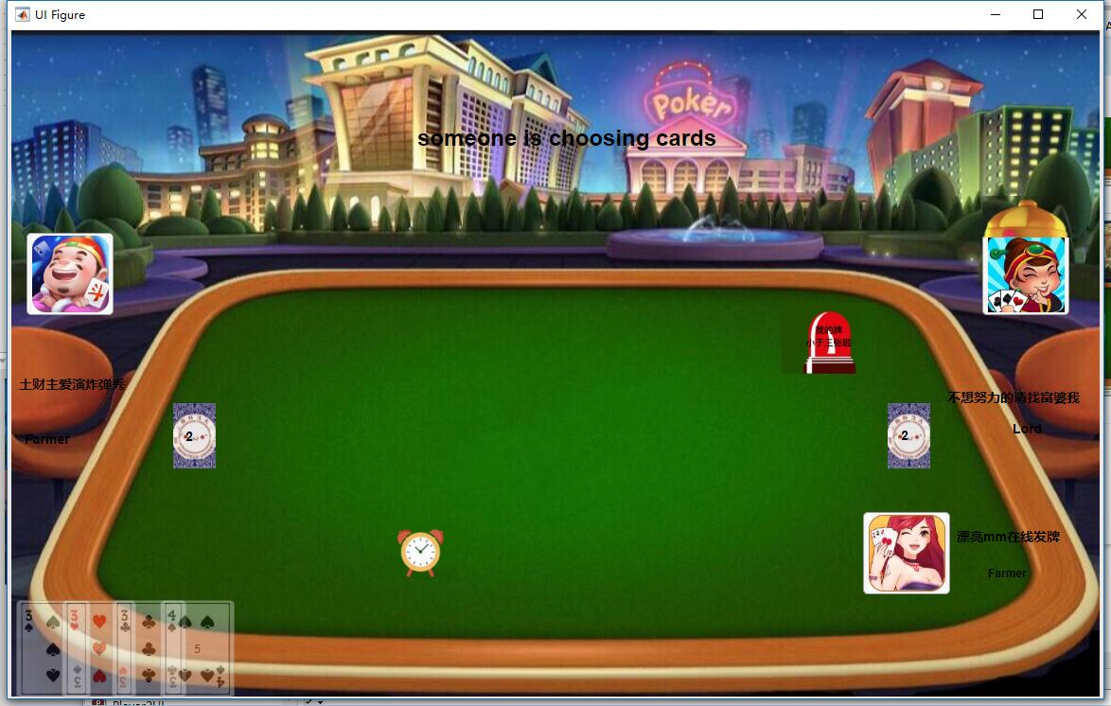

### When someone play all his/her cards system will tell you lord or farmer win

